user software requirements specification

PA Historical Finder

Harrisburg University of Science and Technology

CISC 397, Spring 2018

By Shannon Williams, Daniel Malinsky, Raekwon Harley, Edward Sampson, Sujan Tanniru

Table of Contents

1. Introduction 2

1.1. Purpose 2

1.2. Intended Audience 2

1.3. Product Scope 2

2. User Requirements 2

2.1. Glossary 2

2.2. Use Cases Overview 3

2.3. Use Cases In-Depth 3

2.3.1. US 1- First Time User Login 3

# Introduction

## Purpose

This document serves to explain the user requirements for the software desired.

## Intended Audience

Persons who have an interest in the understanding of the behavior of the system may read this document.

## Product Scope

To the very least, the software must allow users to search for historical information and to view search results in an interactive way.

# User Requirements

## Glossary

User

System

## Use Cases Overview

User requirements will be defined using Use Cases – describing the interaction between actors and the desired system. Figure 1.0 shows a visual representation of an overview of all Use Cases.

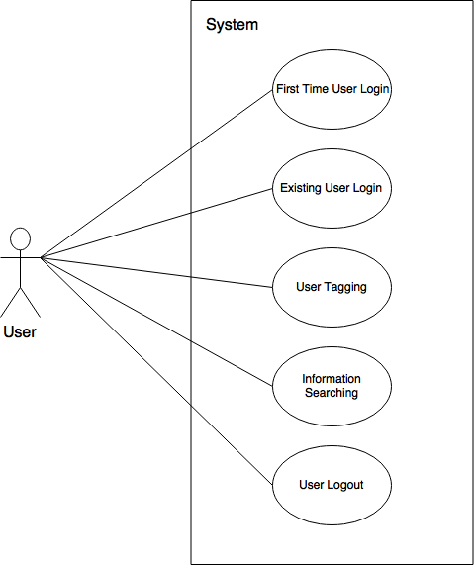

**Figure 1.0 – Use Case Overview Diagram**

### Use Cases In-Depth

## US 1- First Time User Login

**Primary Actor:**User

**Stakeholders (Other Interested Actors):**

* Future Security Team – Would like to see some form of membership framework in place to facilitate future security policy developments.

**Description:** To Explain the process in which the system should respond to a new User (someone who is not registered with the system)

**Main Success Flow:**

1. A new User desires to access the system for the first time so he/she tries to access the system’s services.
2. The system must recognize the User is not recognized.
3. User will be prompted to register with the system using user defined credentials.
4. User enters and submits credentials to the system, which then register the User.
5. System then automatically authenticates the User and gives access to system services.

**Pre-conditions:**

* User must not be registered with the system.

**Post-conditions (always happen after):**

* User will be registered and be recognized by the system in subsequent login attempts with User credentials.

**Special Requirements:** None

**Frequency of Occurrence:**

* Higher occurrences shortly following marketing efforts on media platforms.